|  |  |  |
| --- | --- | --- |
| Sl No | Date | Events |
| 1 | 04/05/2024 | Webinar on Introduction to AI & LLMs in Collaboration with CapX |
| 2 | 21/08/2024 | World Entrepreneurs day |
| 3 | 18/07/2024 | Business Incubation for entrepreneurs program |
| 4 | 25/07/2024 | Seminar on Angel Investment/ VC Funding Opportunity for Early-Stage |
| 5 | 1/08/2024 | Placement awareness program by placement training centre |
| 6 | 23/072024 | Webinar program on introduction to 3D Modeling |
| 7 | 02/06/2024 | Intra Institutional business plan |
| 8 | 04/09/2024 | Introduction to capture the flag |
| 9 | 4/10/2024 | Student Club Inauguration , Recognize the academic excellence |
| 10 | 21/10/2024 | Industrial Visit to KGTTI |
| 11 | 04/12/2024 | Workshop based on Intellectual Property Rights |
| 12 | 13/11/2024 | Workshop on IoT by Student club |
| 13 | 2/6/2024 | Startup Idea Competition |
| 14 | 12/11/2024 | Bag-Free Bonanza-Cultural event from Cultural Club |
| 15 | 4/9/2024 | Technical talk on Cybersecurity Fundamentals |
| 16 | 12/12/2024 | Entrepreneurship in Today's World-Debate Program by Entrepreneurship Club |
| 17 | 13/11/2024 | Introduction to Git and Github-Workshop by Student club |
| 18 | 9/12/2024 | SCR Trip to Somanath Pura,Thalakadu & Shivanasamudra |
| 19 | 06/03/2025-26-03-2025 | Intra college IDEATHON -THINK UP competion |

***Events List***

**DEPARTMENT VISION**

**Be a premier department in the field of Computer Science & Engineering - Artificial Intelligence & Machine Learning (CSE - AIML) to meet the technological challenges of the society.**

**Department Overview**

The Department of Computer Science and Engineering (Artificial Intelligence & Machine Learning) is committed to producing competent professionals with strong technical and research acumen in the field of AI and ML. The department emphasizes practical learning, innovation, industry exposure, and academic excellence.

* **Year of Establishment**: 2021
* **Current Student Strength**:
* **Total Faculty Members**: 15
* **Accreditation Status**: NAAC

**DEPARTMENT MISSION**

**MD1: To facilitate state of the art infrastructure by providing exposure to the latest AI tools used in a technically competent society.**

**MD2: To strive for academic excellence through research in Artificial Intelligence & Machine Learning with creative teaching-learning pedagogy.**

**MD3: To establish Industry Institute Interaction and make students ready for the Industrial environment.**

**MD4: To transform students into entrepreneurial, technically competent, socially responsible, and ethical AI professional.**

**STUDENTS ACHIVEMENTS**

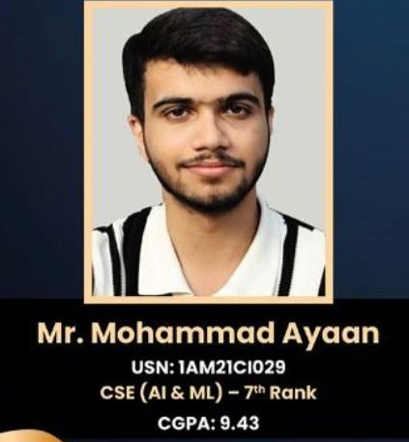

**Proud Achievement: Mohammad Ayyan Secures VTU 7TH Rank**

The Department of Computer Science and Engineering (Artificial Intelligence and Machine Learning) at AMC Engineering College is proud to announce that **Mohammad Ayyan**, a final-year student, has secured a **prestigious VTU Rank** in the university examinations.

This remarkable achievement marks a proud moment for the department, as Mohammad Ayyan becomes the **first VTU rank holder from the CSE-AIML batch**. His dedication, academic excellence, and consistent efforts have brought great recognition to the department.

The Head of the Department, **Dr. Nandeeswar S. B.**, and all faculty members extend their heartfelt congratulations and best wishes for his future endeavors. This milestone sets a benchmark for upcoming batches and serves as an inspiration to fellow students to strive for academic excellence.

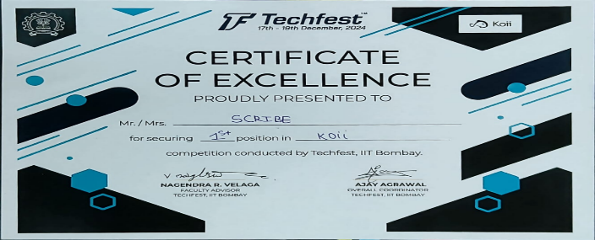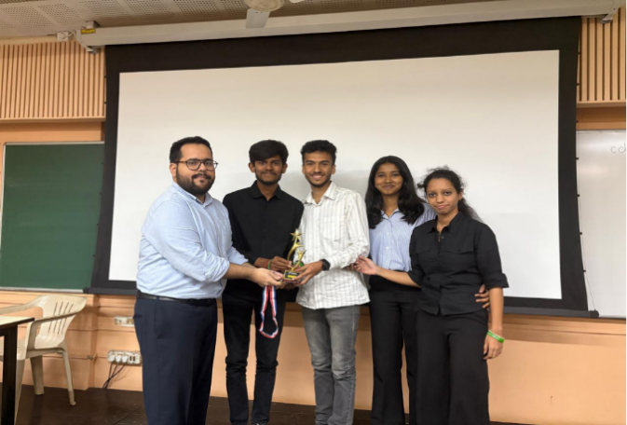

Participated in Hackathon at IIT Bombay and got First Prize by Sanath (1AM22CI088)

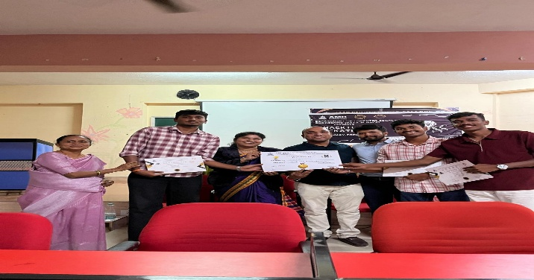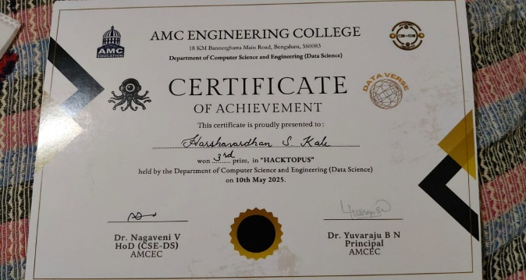

Participated in HACKTOPUS and Won Third place on 10 may 2025 by Harshavardhan S Kale

**FACULTY ACHIEVEMENTS**

|  |  |  |  |  |
| --- | --- | --- | --- | --- |
| **Sl.No.** | **Year** | **Faculty Name** | **Title** | **Name of Journal** |
| **1** | **Feb-24** | **Dr. Nandeeswar S B** | ResNet50-deep affinity network for object detection and tracking in videos | International Journal of Advanced Technology and Engineering Exploration |
| **2** | **Feb-24** | **Dr. Nandeeswar S B** | Mathematical Modelling and Implementation of Multiscale Attention Feature Enhancement Network algorithm for the clarity of SEM and TEM images | International Journal of Intelligent Systems and Applications in Engineering |
| **3** | **Mar-24** | **Dr. Nandeeswar S B** | A framework for brain tumor image analysis using convolution with RELU | International Journal of Intelligent Systems and Applications in Engineering |
| **4** | **Oct-23** | **Dr. Nandeeswar S B** | Wireless Sensor Network Routing Protocols, Challenging Issues in Performance Comparison | Journal of Theoritical and Applied Information Technology |
| **5** | **Sep-23** | **Dr. Nandeeswar S B** | A Smart Biomedical Healthcare system to detect stress using internet of medical things, Machine Learning and Artificial Intelligence | International Journal of Intelligent Systems and Applications in Engineering |
| **6** | **Apr-24** | **Dr. Vijaykumar K** | IOT based robotic device for seed dispersing and pesticide sparying | Design no-41347-001(Indian Patent) |
| **7** | **Dec-24** | **Dr Vijaykumar K** | Management and deployment of 5G small cells and Hetnets using deep learning | Book chapter in Routeledge Taylor and Francis Group |
| **8** | **Apr-24** | **Dr Vijaykumar K** | Graphical User Interface for a Computer Display device | Design no- 6390J11(UK Patent) |
| **9** | **Sep-24** | **Dr Vijayakumar K** | Computer Architecture | Book chapter in Kalyani Publications |
| **10** | **Sep-24** | **Dr Vijayakumar K** | Object Oriented Programming using Java | Book chapter in Kalyani Publications |
| **11** | **Dec-24** | **Dr Vijayakumar K** | Revolutionizing Human Machine Conversations: Real time speech recognition and synthesis with GPT-2 | Proceedings of the 3rd International Conferences on Optimization Techniques in the field of Engineering |
| **12** | **Dec-24** | **Dr Vijayakumar K** | The application of Machine Learning to NLP: Mordern Advances in the study of Human Language | 3rd International Conference on Sustainable Technologies and Advances in Automation, Aerospace and Robotics |
| **13** | **Dec-24** | **Dr Vijayakumar K** | Securing Space Tourism Operations using Blockchain Technology. | ID: 202441067348(Indian Patent Filed) |
| **14** | **Feb-25** | **Prof Swathi S A** | VBOT: An AI Powered chatbot for streamlining college administration and enhancing student engagement | International Journal of Research and Analytical Reviews |
| **15** | **Apr-25** | **Prof Swathi S A** | State of the art Review on Chatbot for College Enquiry | International Journal of Scientific Research in Engineering and Management |
| **16** | **Jan-25** | **Prof Swathi S A** | Real-time distress signal recognition: Acoustic monitoring for crime control | International Research Journal of Engineering and Technology |
| **17** | **Jan-25** | **Prof Swathi S A** | Object detection based on Python and Image Processing | International Journal of Artificial Intelligence Research and Development |
| **18** | **Nov-24** | **Prof Swathi S A** | State of the art review on image synthesis with generative adversarial networks | International Research Journal of Engineering and Technology |
| **19** | **Mar-24** | **Prof Swathi S A** | AI Based Goggles for Visually Impaired | Patent ID 410787-001The Patent office, Government of India |
| **20** | **Jan-25** | **Prof Swathi S A** | Analysing and predicting the control of GHG emissions using Machine Learning Models | Artificial Intelligence and Software Engineering: Tools,Techniques and future trends, Bright Sky Publications |
| **21** | **Mar-25** | **Prof Swathi S A** | Digital Survival: Navigating Internet vulnerabilities in the modern era | International Journal of Scientific Research in Engineering and Management |
| **22** | **Jan-25** | **Prof Swathi S A** | AI driven Social Media Platform Profanity- Free | International Journal of Research and Analytical Reviews |
| **23** | **Jan-25** | **Prof Sreenivasaperumal** | Performance Evaluation of children at risk for schizophrenia using ensemble learning | Book Chapter in Smart Factories for Industry 5.0 Transformation |
| **24** | **Feb-25** | **Prof Sreenivasaperumal** | Boosting Deep Learning Models with Improved Artificial Gorilla Troops Algorithm for real time object detection and classification on self driving cars | SCI Journal |
| **25** | **Dec-24** | **Prof Sreenivasaperumal** | Innovations in Cybersecurity and Data Science | Proceedings of ICICDS Book chapter in Springer |
| **26** | **Sep-23** | **Prof Sreenivasaperumal** | A review of Convolution Neural Networks(D-CNN) Models | Book Chapter in AETS Global |
| **27** | **Jan-25** | **Prof Ambili K** | Object detection based on Python and Image Processing | International Journal of Artificial Intelligence Research and Development |